A good example of Chart Junk is the following graph below:
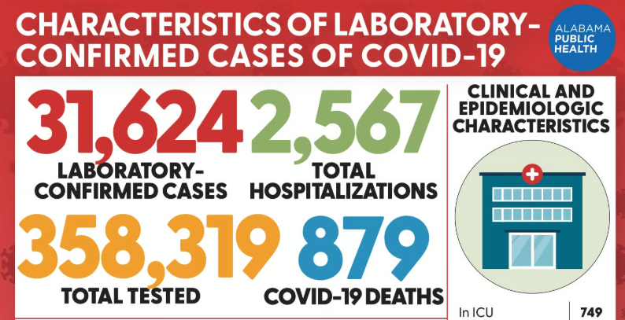
Chart Junk is the excessive and unnecessary use of graphical effects in a graph. The above graph has important information regarding Covid-19 testing and deaths. However, with the numbers and words being so close together, large, and crowded, they can cause confusion for the audience.

Now, let’s compare that to a graph that successfully displays a large amount of data effectively
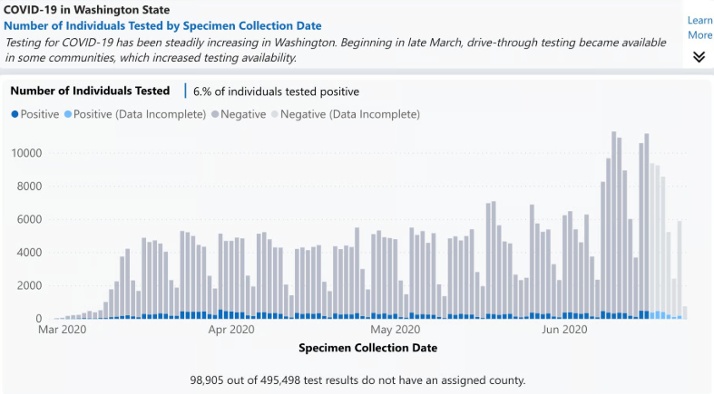
In this case, we are also seeing a large amount of information over a large time period. However, in this case, one can more effectively see the “bigger picture” of these trends (like total amount tested, total positive tests, total negative tests) and the finer details (the total amount tested positive and negative in each month) in a clearer way than the graph above.

Now when it comes to the Lie Factor, we can see the graph below:
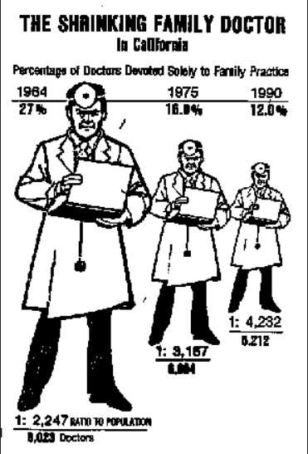
In this graph, we see that the percentages of doctors drops from 27% down to 12%. While the percentage of doctors in 1964 is over double the amount in 1990, we run into problems with our 2-dimensional graph. Specifically, the changing with the doctor images happens with both height and width. This causes the doctor on the left to be much larger than the doctor on the right, signifying a much bigger change than in reality. While our data changes by 125% [(27-12)/12 = 1.25 * 100 = 125%] but our graph changes by 406%. As a result, we have a lie factor of 406/125 = 3.8.

Works Cited
Foley, Katherine Ellen. “How Bad Covid-19 Data Visualizations Mislead the Public.” Quartz, qz.com/1872980/how-bad-covid-19-data-visualizations-mislead-the-public?utm_source=chatgpt.com. Accessed 17 Oct. 2025.

Giard, David. “Data Visualization, Part 3: Graphical Integrity.” David Giard, 10 May 2011, davidgiard.com/data-visualization-part-3-graphical-integrity?utm_source=chatgpt.com. Accessed 17 Oct. 2025.

